केन्द्रीय विद्यालय तुली / KENDRIYA VIDYALAYA TULI
शिक्षा मंत्रालय, भारत सरकार के अधीन स्वायत्त निकाय
(An Autonomous Body under Ministry of Education, Government of India)
डाकघर–पेपरनगर तुली, जुडीकोंग टाउन / P.O.-Paper Nagar Tuli, Tzudikong Town जिला-मोकोकचुंग, नागालैंड-798623 / Distt.-Mokokchung Nagaland-798623
स्कूलकोड-39381, स्टेशनकोड-509/ School Code – 39381, Station Code – 509
CBSE Affiliation No.1400001 & स्कूल सं / School No.1895
दूरभाष/Tel. : 03691-271287 वेबसाइट /Website :www.tuli.kvs.ac.in, ई-मेल/E-mail :kvtulinagaland1895@gmail.com
F.No.1895/KVT/2023-24/Acad./ Date /दिनांक: 13/03/2023
Email/Speed post

साक्षात्कार
सत्र 2024-25 के लिए रिक्त पद स्नातकोत्तर शिक्षक’ (हिन्दी, अंग्रेजी, गणित, भौतिक विज्ञान, रसायन विज्ञान, जीव विज्ञान, भूगोल, अर्थशास्त्र, इतिहास और संगणक विज्ञान), प्रशिक्षित स्नातक शिक्षक (हिंदी, अंग्रेजी, गणित, विज्ञान, संस्कृत), प्राथमिक शिक्षक और विशेष शिक्षक, खेल प्रशिक्षक, योग प्रशिक्षक, चांसलर, नर्स और कंप्यूटर अनुदेशक पर पूर्णतः संविदा के आधार पर नियुक्ति हेतु पैनल तैयार करने के लिए साक्षात्कार दिनांक 20.03.2024 (दिवस- बुधवार) को विद्यालय परिसर में आयोजित किया जा रहा है |
नोट:-
* आवदेन-पत्र एवं विस्तृत विवरण हेतु विघालय की वेबसाइट www.tuli.kvs.ac.in पर लॉग इन करें|
* साक्षात्कार हेतु किसी भी प्रकार के यात्रा व्यय का भुगतान नही किया जाएगा |

प्राचार्य
केन्द्रीय विद्यालय तुली नागालैंड

WALK IN INTERVIEW

For setting up the panel of purely part time contractual staff for the Session 2024-25 in Kendriya Vidyalaya Tuli, Walk-in Interviews are arranged on 20th March 2024 (Wednesday) at 08:00 am to 12:00 pm for the following posts:
- PGTs – English, Hindi, Mathematics, Physics, Chemistry, Biology, Economics, Geography, History, and Computer Science
- TGT (Hindi, English, Mathematics, Science, Sanskrit)
- PRTs, Special Educator, Games Coach, Yoga Instructor, Chancellor, Nurse and Computer Instructor
Note:
- Registration for all the posts will be done on 20th March 2024 (Wednesday) from 8:30am to 09:30am. No candidate will be allowed after 09:30AM.
- Aspirant candidate must remain present on the decided day and time along with their duly filled application form (download from the school website), original copies of certificates, experience letter along with self attested photocopies.
- Visit school website: www.tuli.kvs.ac.in for application form and other necessary details.
- No TA/DA will be paid for attending the interview.

PRINCIPAL
KENDRIYA VIDYALAYA TULI NAGALAND

KENDRIYA VIDYALAYA TULI NAGALAND

Kendriya Vidyalaya TULI NAGALAND invites applications from the intending eligible candidates for preparing panel/ appointment of Contractual Teachers for the under mentioned posts (Session 2024-25).

POSTS:
- PGTs (English, Hindi, Mathematics, Physics, Chemistry, Biology, Computer Science, History, Geography, Economics)
- TGTs (English, Hindi, Mathematics, Science, Sanskrit)
- PRTs
- Computer Instructor
- Games Coach
- Yoga Coach
- Nurse
- Academic Counselor

IMPORTANT

- CANDIDATES TO ENSURE THEIR ELIGIBILITY FOR THE POST.

The candidates applying for the post should ensure that they fulfill all eligibility conditions. Their admission at all the stages of the recruitment process will be purely provisional subject to satisfying the prescribed eligibility condition(s).

The K. V. Tuli, Nagaland takes up verification of eligibility conditions with reference to original documents only after the candidates have qualified for interview.

APPLICATION FORM:

Candidates must apply in the Common Application Form devised by the K. V. Tuli, Nagaland for this recruitment process and available with the advertisement inviting applications or may be downloaded from the Vidyalaya web site with U.R.L. (www.tuli.kvs.ac.in)

EXAMINATION FEES / APPLICATION FEE: NIL.

- DOCUMENTS TO BE ATTACHED WITH THE APPLICATION

Two copies of recent photograph (size 35 x 45 mm) facing camera, out of which one duly self attested and one without attestation should be affixed with the application form.

Attested photocopies of all the educational qualifications, academic and professional, mark- sheets for all the years, degree/ diploma certificates starting from Senior Secondary/ Intermediate to highest academic/ professional qualification the candidate possesses, all certificates in claim of CCA, achievements/ distinction in Sports, Literary activities, Scouts & Guides, NCC, NSS etc., class X certificate for proof of date of birth, experience certificates etc. duly tagged with application together (All Certificates shall be self attested).

CORRESPENDENCE WITH THE K. V. TULI NAGALAND

The K. V. Tuli, Nagaland will not enter into any correspondence with the candidates about their candidature.
The candidates should note that their admission to the recruitment process will be purely provisional based on the information given by them in the application form. This will be subject to verification of all the eligibility conditions by the K. V. Tuli, Nagaland.
Candidates may note that the K. V. Tuli, Nagaland takes up the verification of eligibility conditions of a candidate, with reference to original documents, only after the candidate has qualified for interview. Unless the candidature is formally confirmed by the K. V. Tuli, Nagaland, it continues to be provisional.
The decision of the K. V. Tuli, Nagaland as to the eligibility or otherwise of a candidate for admission to the recruitment process shall be final.
A. POST GRADUATE TEACHERS

ESSENTIAL QUALIFICATIONS:
- Two years integrated Post Graduate M.Sc. Course of Regional Institute of Education of NCERT in the concerned subject;
OR
Master's Degree from a recognized University with at least 50% marks in aggregate in the following subjects: -
S.N | Name of Post/  Subject | Subject(s)
1. | PGT (English) | English
2. | PGT (Hindi) | Hindi or Sanskrit with Hindi as one of the subjects at Graduate  level
3. | PGT (Physics) | Physics/ Electronics/ Applied Physics/ Nuclear Physics
4. | PGT (Chemistry) | Chemistry/ Bio. Chemistry
5. | PGT (Economics) | Economics/ Applied Economics/ Business Economics
6. | PGT (Mathematics) | Mathematics/ Applied Mathematics
7. | PGT (Biology) | Botany/ Zoology / Life Sciences/ Bio Sciences/ Genetics/ Micro Biology/ Bio-Technology/ Molecular Biology/ Plant Physiology  provided they have studied Botany and Zoology at Graduation level
8. | PGT (History) | History
9. | PGT (Geography) | Geography

- B.Ed. or equivalent degree from a recognized University.
- Proficiency in teaching through Hindi and English medium.

Note: Candidates having Special B.Ed. are not eligible for the post of PGT. Desirable Qualification: Knowledge of Computer Applications.

B. POST GRADUATE TEACHERS (COMPUTER SCIENCE)

ESSENTIAL QUALIFICATIONS:
i.

S.No | Name of Post/ Subject | Qualification (s)
1. | PGT (Computer Science) | Essential:  1. At least 50% marks in aggregate in any of the following:  B.E or B.Tech (Computer Science/ IT) from a recognized University or an equivalent Degree or Diploma from an institution/ university recognised by the Govt. of India.  OR
B.E or B.Tech (any stream) and Post Graduate Diploma
in Computers from any recognized University OR
M.Sc. (Computer Science)/ MCA or Equivalent from
a recognized University. OR
B.Sc. (Computer Science)/ BCA or Equivalent and Post
Graduate degree in any subject from a recognized
University. OR
Post Graduate Diploma in Computer and Post Graduate degree
in any subject from a recognized University. OR
 |  | ‘B’ Level from DOEACC and Post Graduate degree in any subject. OR
‘C’ Level from ‘DOEACC’ Ministry of Information
and Communication Technology.
ii. Proficiency in teaching in Hindi and English medium.
C. TRAINED GRADUATE TEACHERS:

ESSENTIAL QUALIFICATIONS:

- Four Years Integrated Degree Course of Regional College of Education of NCERT in the concerned subject with at least 50% marks in aggregate; or
Bachelor's Degree with at least 50% marks in the concerned subject/ combination of subject and in aggregate. The elective subjects and languages in the combination of subjects as under:
S.No. | Name of Post/  Subject | Subject(s)
1. | TGT (English) | English as a subject in all the three years.
2. | TGT (Hindi) | Hindi as a subject in all the three years.
3. | TGT (Science) | Botany, Zoology and Chemistry.
4. | TGT (Sanskrit) | Sanskrit as a subject in all the three years.
5. | TGT (Maths) | Bachelor Degree in Maths with any two of the following subjects: -  Physics/ Chemistry/ Electronics/ Computer Science/  Statistics

- B.Ed. or equivalent degree from a recognized University.
- Central Teacher Eligibility Test (CTET) conducted by the CBSE
- Proficiency in teaching in Hindi and English medium.
Desirable: Knowledge of Computer Applications.

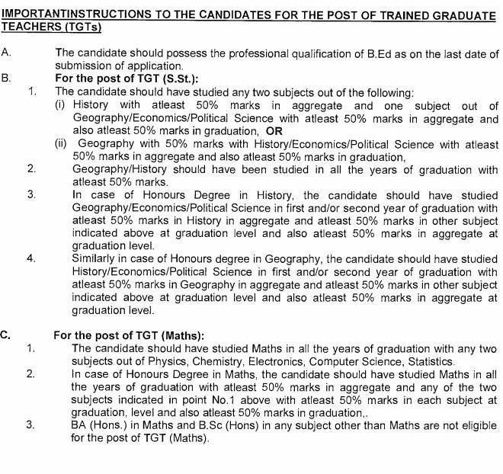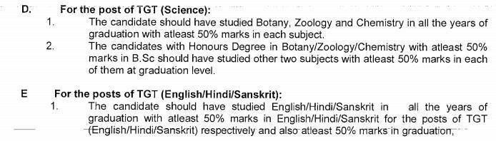

D. PRIMARY TEACHERS

ESSENTIAL QUALIFICATIONS:

S.No. | Short name of post | Qualification (s)
1. | PRT | Essential:  i) Senior Secondary School Certificate with 50% marks or Intermediate with 50% marks or its equivalent;  Pass in the Central Teacher Eligibility Test (CTET) conducted by the CBSE in accordance with the Guidelines framed by the NCTE for the purpose.  (iii) The candidate should posses two years Diploma in Education (D.Ed.) or Bachelor in Elementary Education (B.El.Ed.) and  ii) iv) Competence to teach through Hindi and English medium.
Desirable: Knowledge of Computer Applications.
E. COMPUTER INSTRUCTOR (PRIMARY & SECONDARY)

Essential:
- BE/ B. Tech (Computer science)/ BCA/ MCA/ M.Sc. (Computer Science) Or

- M.Sc. (Electronics with Computer Science component)/ M.Sc. (IT)/B.Sc. (Computer Science) Or

- Bachelor’s/ Master Degree in any Science subject/ Mathematics from recognized university with Postgraduate Diploma in Computer application from government recognized University/ Institute. Or

- Post-graduate degree in any subject with Postgraduate Diploma in Computer application from government recognized University/ ‘O’ level from DOEACC. Or

- Post-graduate degree in any subject with minimum ‘A’ level from DOEACC.

- Competence to teach through Hindi and English medium.

F. GAMES & SPORTS COACHES

Essential:
Bachelor’s Degree in Physical Education or equivalent.
- Competence to teach through English and Hindi medium.
Desirable: Knowledge of Computer Applications.

G. YOGA COACH
Essential:
Graduation in any subject or equivalent from a recognized university with one year training in Yoga from a recognized institution.
Desirable: Knowledge of Computer Applications.
H. COUNSELLOR

Essential:
B.A. / B. Sc. (Psychology) with Certificate of Diploma in Counseling.
Desirable: (i) Minimum of one year Experience in providing career Education counseling to students at school

OR
Working knowledge and experience in placement Bureaus.

OR
Registration with rehabilitation council of India as vocational counselor.
I. Nurse

Essential:
Diploma in nursing.
Desirable: Knowledge of Computer Applications.

SPECIAL PROVISION
Relaxation of B.Ed. qualification - In the absence of suitable candidates with B.Ed. Degrees in Hard/ Very Hard station and in remote areas of North- East and J&K, candidates with following qualification may be considered in different categories without B.Ed. qualification –
- Post graduate with 60% marks in Science subjects and 55% in Humanities subjects may be considered for the posts of PGTs, if suitable candidates with B.Ed. are not available.
- Similarly in the case of TGT, B.Sc. with 60% marks and BA with 55% marks may be considered for appointment on part-time contractual basis if suitable candidates with B.Ed. are not available.
- Graduates may be considered for the post of Primary Teacher if candidates with Senior Secondary/ Plus 2/ Inter with J.B.T. qualification are not available.
ii) Relaxation in CTET – In the absence of CTET qualified candidate, candidate without CTET qualification may be considered if otherwise eligible as per KVS recruitment rules.

PART - VI : SPECIAL INSTRUCTIONS TO THE CANDIDATES
- Qualifications acquired by the candidates should be strictly in accordance with the
prescribed qualifications and candidate should not seek claim of equivalence of their qualifications with that of qualifications as asked for. Wherein grades have been given, equivalence marks of gradation should be attached.
- The Candidate should not fill in those qualifications in the application form for which they have appeared in any of the examination whose result is awaited/ withheld/ not declared.
- A candidate must apply separately for different posts.
- Canvassing in any form will disqualify a candidate.
- No TA/DA will be paid for appearing in the walk-in- interview

